A000-US-Pipe-Lakota Sioux-Snake Effigy-1910

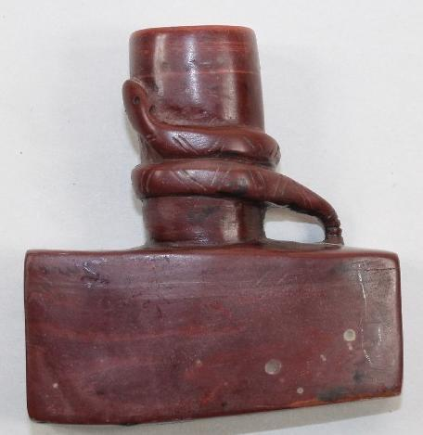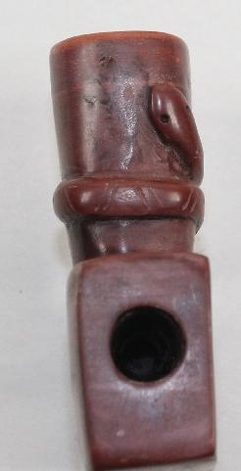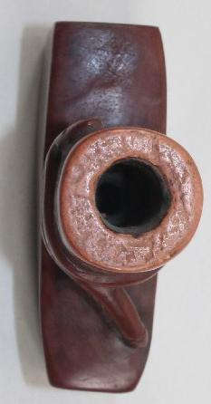

Case no.: 12

Accession Number:

Formal Label:

**Display Description:**

**LC Classification:**

Date or Time Horizon:

Geographical Area:

**Map:**

**GPS coordinates:**

Cultural Affiliation:

Media:

Dimensions:

Weight:

Condition:

Provenance:

**Discussion:**

**References:**

almost 3" long T-Bowl Pipe that is 3" tall by 1" wide. This pipe is unique because it has a rattlesnake carved around the bowl. Most likely this pipe was made around the 1910-1920's and sold to tourists. It has definitely been used. The bowl is 1/2" by 1-1/2" deep. The stem hole is 7/16" in diameter. This pipe has been well used. Around the top of the bowl it has been beat on quite a bit to knock the tobacco out of it.